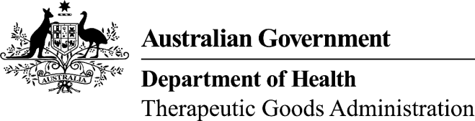
TGA use only
Committee session:
Date approved:
Regulatory area:
Reference:
This form, when completed, will be classified as 'For official use only'.
For guidance on how your information will be treated by the TGA see: Treatment of information provided to the TGA at <http://www.tga.gov.au/about/tga-information-to.htm>.

Proposed name for a chemical substance (AAN) used in therapeutic goods
Application form
Please note: This application will be considered by the TGA’s Australian Approved Names (AAN) Committee. The Committee will endeavour to consider the application within 20 working days. Following consideration, the Committee may ask the application for additional information where the application is incomplete or unclear, e.g. where the substance has not been clearly defined.
Refer to TGA approved terminology of medicines Section 1 – Chemical Substances – 1.1 Explanatory Notes for information on the naming of chemical substances.
Please note that the Committee only reviews the name and definition of an ingredient. The use of an ingredient is approved by other areas of the TGA.

1. Proposed chemical substance name

2. Synonym(s)

3. Structure and/or definition: (Including waters of hydration)

4. The substance is expected to be used as:
Active ingredient: Excipient ingredient:

5. The substance is expected to be used in a:
Listed medicine
Prescription Medicine
Orphan drug? Yes No
Over the counter (OTC) medicine
Registered complementary medicine
Proprietary Ingredient Formulation
Device
Export only medicine

6. Product name (if known):

7. Route of administration:
Oral Topical Other (please specify)
Please specify:

8. References
This section must be completed. Please place a tick in the box next to the reference(s) containing the proposed name, and enter the reference details (edition, volume, etc.).
The reference(s) must refer to the name proposed, and a full copy of the relevant reference(s) must be provided.
TGA naming policy is to use the International Non-proprietary Name (INN) for a substance, wherever one exists. If an INN exists for a given substance, the applicant must justify the use of an alternative name. References are listed in approximate order of preference.
Note on citations: When citing a print version, provide full details including title, author details if applicable, edition, volume and pagination.
When citing an electronic version, provide full details including title, authority and platform where applicable, including version number. Specify medium accessed (for example web, CD-ROM). For internet sites, also provide the URL and date accessed.

 | Ref. Code | Edition, Year, Volume | Reference
 | INN |  | International Non-proprietary Names
 | BP |  | British Pharmacopoeia
 | BAN |  | British Approved Names
 | USP |  | United States Pharmacopoeia
 | USAN |  | United States Adopted Name
 | BPAP |  | British Pharmacopoeia - Appendix
 | EP |  | European Pharmacopoeia
 | MAR |  | Martindale, the Extra Pharmacopoeia
 | MI |  | Merck Index
 | FCC |  | Food Chemicals Codex
 | ANZFS |  | Australia New Zealand Food Standards Code
 | ICID |  | International Cosmetic Ingredient Dictionary
 | CAS |  | CAS Registry (Chemical Abstracts Service)
 | CHEM |  | CHEMID plus (National Library of Medicine)
 | CI |  | Colour Index (Society of Dyers and Colourists)
 | ALL |  | Allured’s Flavour and Fragrance Materials
 | FHF |  | Fenaroli’s Handbook of Flavour Ingredients
 | FIE |  | Fiedler Encyclopedia of Excipients
 | HPE |  | Handbook of Pharmaceutical Excipients
Other (please specify):

9. Applicant details
Name |  |  | Sponsor: Agent:
Position
Company
Client ID
Address
Telephone |  | Fax
Email
The completed form and attachments can be sent by email or post:
Email: TGAnames@tga.gov.au
Post: The Secretariat
Australian Approved Names Committee
Office of Scientific Evaluation
Therapeutic Goods Administration
PO BOX 100
WODEN ACT 2602

