Evaluation of substances for use in listed and assessed listed medicines
  - Application user guide
Version 2.0, August 2020

Copyright
© Commonwealth of Australia 2020
This work is copyright. You may reproduce the whole or part of this work in unaltered form for your own personal use or, if you are part of an organisation, for internal use within your organisation, but only if you or your organisation do not use the reproduction for any commercial purpose and retain this copyright notice and all disclaimer notices as part of that reproduction. Apart from rights to use as permitted by the Copyright Act 1968 or allowed by this copyright notice, all other rights are reserved and you are not allowed to reproduce the whole or any part of this work in any way (electronic or otherwise) without first being given specific written permission from the Commonwealth to do so. Requests and inquiries concerning reproduction and rights are to be sent to the TGA Copyright Officer, Therapeutic Goods Administration, PO Box 100, Woden ACT 2606 or emailed to <tga.copyright@tga.gov.au>.

Contents
Introduction 5
Accessing the TGA Business Services (TBS) 5
How to login 5
Open/Create a Substance Evaluation application 7
Edit an existing draft application 7
Delete an existing draft application 7
Create a new application 7
Step 1 – Organisation details 9
Submit on behalf of another organisation 10
Who is responsible for payment of the invoice? 11
Who is the contact for more information? 11
Step 2 – Application details 13
Application to include a new substance 13
Are you requesting exclusive use? 13
Does the substance have an Australian approved name? 14
Application category 14
Application to modify an existing ingredient 15
Select the ingredient you propose to modify 15
Application category 16
Step 3 – Proposed use 17
Application to include a new substance 17
Application to modify an existing ingredient 18
Step 4 – Substance details 20
Is the substance a single constituent that can be readily characterised? 20
Is the substance subject of a default standard? 20
Is the substance of animal or human origin? 20
Step 5 – Supporting documentation 21
Attached to the application 21
Send separately 22
Step 6 – Declaration 23
Application summary 23
Declaration 24
After submission 25
Fees 26
Related information and guidance 26
Troubleshooting 27

Introduction
This guidance is intended for applicants using the TGA Business services (TBS) portal to complete an online application form for a new substance to be evaluated for use as an ingredient in a listed or assessed listed medicine or to change the purpose and/or requirements associated with an ingredient already permitted for use in a listed or assessed listed medicine.
When an application is approved, a recommendation will be made to vary the determination made under section 26BB of the Act (the Therapeutic Goods (Permissible Ingredients) Determination) to permit the use of the ingredient in listed or assessed listed medicines.
A submission dossier will need to either be attached to the application or sent separately. Please see Applications for new substances in listed medicines - Australian regulatory guidelines, in particular Table 1: Application categories for evaluation of substances.

Accessing the TGA Business Services (TBS)
You will need a TGA client ID to access the TBS portal, please see TGA Business Services: getting started with the TGA.
Information regarding the various ‘roles’ within TBS can be found at TGA Business Services - how to use the site under Roles: what each user can do.
The TBS portal can be accessed through your web browser using either Internet Explorer, Google Chrome, Firefox or Safari.

How to login
Once you have your login details, log on to the TBS portal. You will be prompted to enter your login details on the right hand side of the screen.
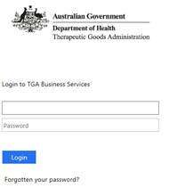
 | Username and password are case sensitive.
Once logged in, you will see a personalised work page or ‘dashboard’.
What you can see and do on the dashboard will depend on your user role (access level).
For further information, see TGA Business Services: getting started.
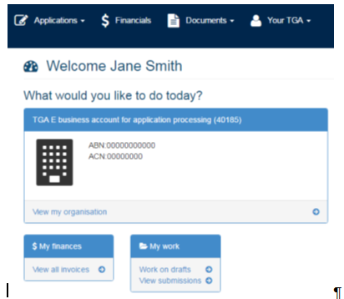
In the dashboard menus: Applications, Documents and Your TGA are displayed.
If you also have financial access, the Financials menu will be displayed.
On the dashboard, you can:
- Access the ‘My work’ menu to work on drafts or view submissions;
- Access the ‘$ My finances’ to view invoices;
- Access the ‘News Panel’ to view the latest TGA news;
- Access the ‘Work on drafts’ and ‘View submissions’ to view all draft and submitted applications;
- View the ‘Applications menu’ – the drop down will display all application types available;
- View the ‘Documents menu’ – the drop down will display manufacturers, Consumer Medicine information and Product information;
- Access the ‘View my organisation’ to edit user details;
- View the ‘Your TGA menu’ – the drop down will display your current ARTG entries and other useful information.

Open/Create a Substance Evaluation application
Select the ‘Application’ drop down arrow and under the Listed Medicine subheading and select ‘Substance Evaluation’.
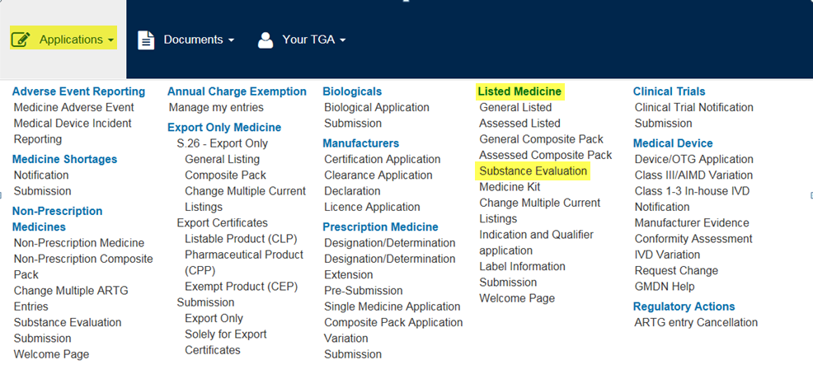
The Substance Evaluation dashboard will be displayed:
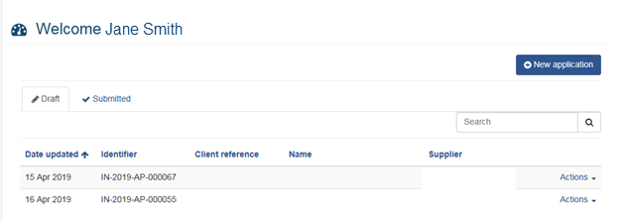
The dashboard will display your client name and draft applications. You can review submitted applications by selecting the Submitted tab.

Edit an existing draft application
Select the drop down arrow in the ‘Actions’ column next to the application you wish to edit and the ‘edit’ button. The application will open at Step 1. You will have to work through each of the steps of the application, regardless of whether these steps have been previously completed. You are unable to skip ahead to other steps.

Delete an existing draft application
Select the drop down arrow in the ‘Actions’ column next to the application you wish to delete and the ‘delete’ button. The application will be deleted.

Create a new application
Select the ‘New application’ button on the right hand side of the dashboard.
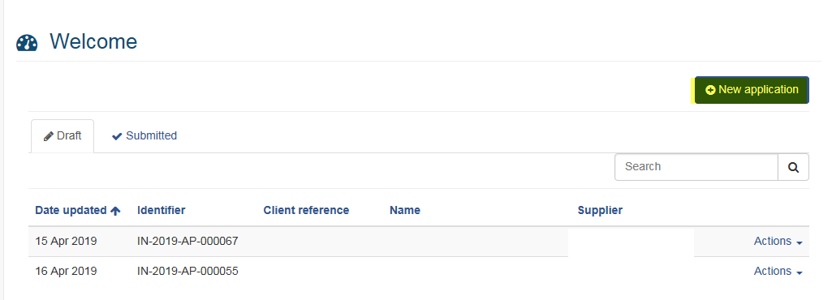
The Listed medicines ingredient application form is displayed and is divided into six steps:
- Step 1 - Organisation details
- Step 2 - Application details
- Step 3 - Proposed use
- Step 4 - Substance details
- Step 5 - Supporting document
- Step 6 – Declaration
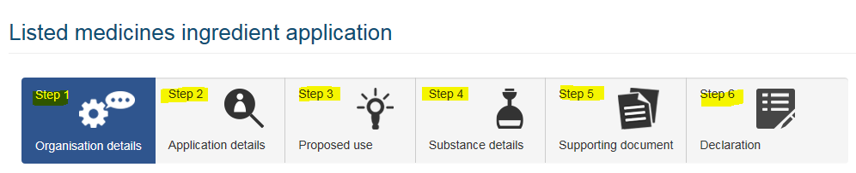
The application form must be completed from Step 1 through to Step 6 consecutively. Each step is required to be completed before moving on to the next step.
All mandatory fields within the form are denoted with an * asterisk

Step 1 – Organisation details
The applicant is the organisation who is logged into the TBS portal and is completing the form. The applicant can be registered as an agent, sponsor or manufacturer in TBS Client database.
If the applicant is an agent in TBS Client database, they can submit an application on behalf of a sponsor or manufacturer organisation.
The supplier is the organisation who is responsible for the application and if appropriate, will be granted exclusive use of the ingredient. The supplier must be registered as a sponsor or manufacturer in TBS Client database.
The Applicant Name will be prepopulated from your log on.
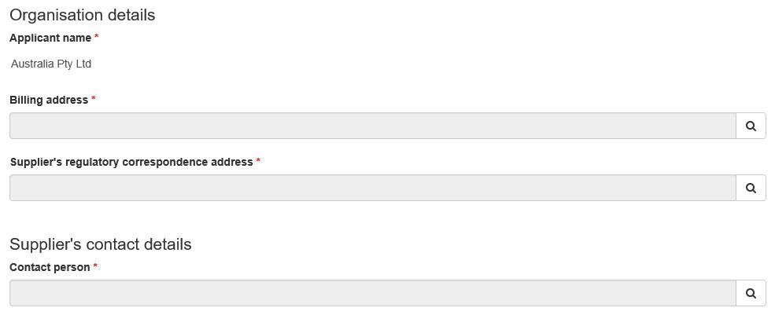
Select magnifying glass icon  to complete the following fields:
- Billing address
- Supplier’s regulatory correspondence address
- Supplier’s contact details – Contact person
A window will open with the available options. Click on the ‘Select’ button to enter your option in the application. Repeat this process for all mandatory fields.
To remove the information, select the magnifying glass icon next to the field and select the ‘remove value’ field.
When a contact person is selected, their telephone number and email will prepopulate. If these details are not correct, you will need to update these before creating this application. For further information, see TGA Business Services: getting started.
The contact person must be registered in the TBS Client database and have the ‘submitter’ role. If not, an Organisation Details form will need to be completed.
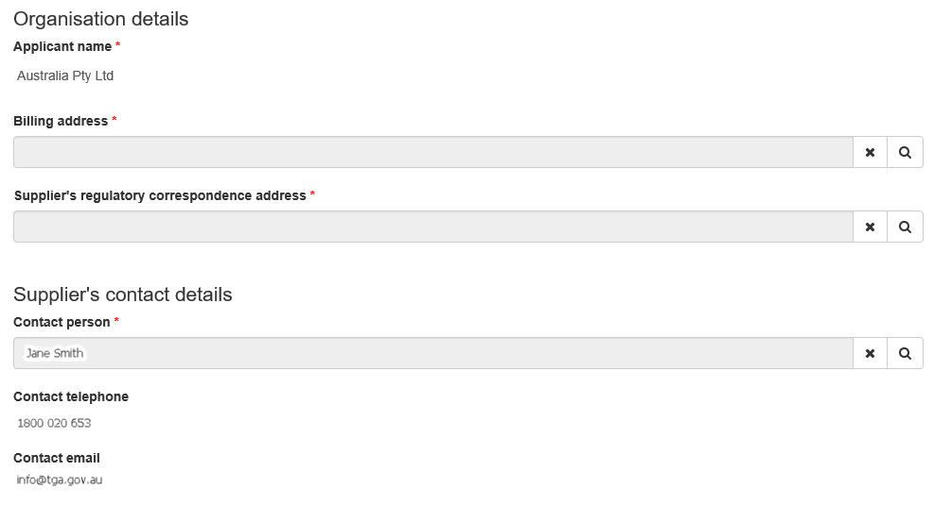
Please ensure that the nominated contact person is available throughout the evaluation process to respond to any questions the TGA may have.
If the contact person or the contact information changes during the evaluation process, contact the TGA at complementary.medicines@health.gov.au and advise the new contact person.

Submit on behalf of another organisation
When your organisation is registered in the TBS Client database as an agent, an additional mandatory field will be displayed ‘Is the applicant the supplier’. This will enable you to lodge an application for yourself or on behalf of another organisation.
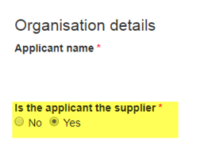
If you select ‘No’, you must select a supplier from the drop down list:
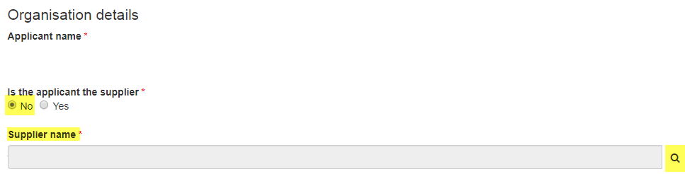
Only organisations that are registered in TBS as a ‘sponsor’ or ‘manufacturer’ and you have been authorised to act as an agent in TBS will appear.
If your organisation is only registered as an agent, you must select another organisation to be the supplier. If this is not correct, you will need to update your details in TBS before starting this application. For further information, see TGA Business Services: getting started.
Additional mandatory fields are now displayed:
- Who is responsible for payment of the invoice?
- Supplier’s regulatory correspondence address
- Applicant’s regulatory correspondence address
- Supplier’s contact details – contact person
- Who is the contact for more information?

Who is responsible for payment of the invoice?
If you select Applicant in the Billing address field, the address of the applicant will be displayed and must be selected.
If you select Supplier in the Billing address field, the address of the supplier will be displayed and must be selected.

Who is the contact for more information?
Enter the supplier’s contact details. You can nominate an individual person who you would prefer we contact for more information about the application.
A contact person must be an individual registered with TBS as a ‘submitter’.
If you prefer we contact you as the agent organisation, select Applicant. A mandatory field will appear below for the ‘Applicant’s contact details’. You will be able to select an individual person from your organisation as the contact person, in addition to a contact from the supplier organisation.
If you prefer we contact the organisation nominated as the supplier, select Supplier. You will only be able to select an individual person from the supplier’s organisation in the field above. A field will not appear under ‘Who is the contact for more information?’.
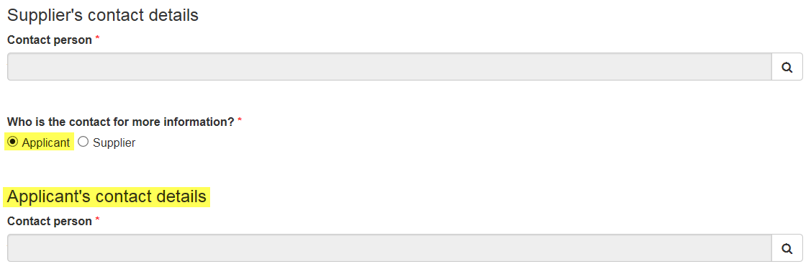
When all mandatory fields have been completed, select ‘Next Step’ to proceed to Step 2.
If you leave the page before selecting ‘Next Step’, any information already entered on that page will be lost.

Step 2 – Application details
The client reference is an optional field used by the supplier to identify the application. This name will not be used by TGA.
The client reference has a maximum of 100 characters.
This application form can be used to apply for a new substance or to modify an ingredient that is already permitted for use in listed medicines.
If you are not sure of the current status of your substance, you should look for the ingredient in the TGA’s Ingredient search on TBS. If the ingredient already has a TGA approved name, this ingredient search will indicate whether it has been approved for use in listed medicines (or ‘listable’). Open the ‘Ingredient summary’ to access the current availability and requirements under the ‘Restrictions’ section.

Application to include a new substance
To apply for a new substance, select the ‘Include a new substance’ radio button in the ‘Is the application to vary the Therapeutic Goods (Permissible Ingredients) Determination to’ field.
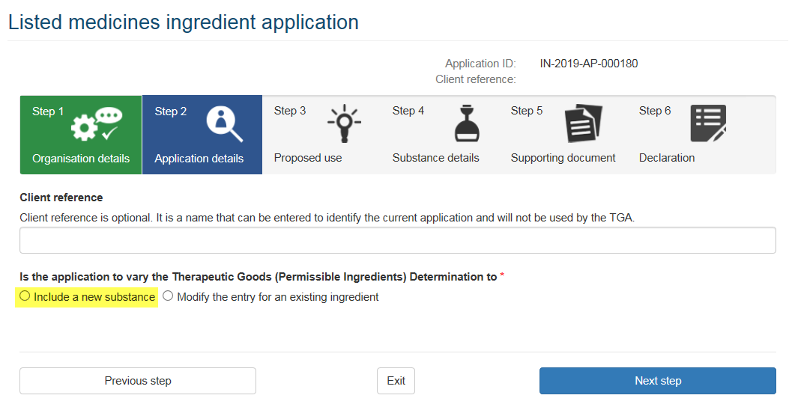
Complete the additional fields that are displayed:

Are you requesting exclusive use?
Select ‘Yes’ if you wish to request exclusive use for a period of two years.
For further information on the eligibility criteria for market exclusivity, refer to Ingredients that are eligible for exclusivity in Applications for new substance in listed medicines - Australian regulatory guidelines.

Does the substance have an Australian approved name?
Prior to submitting your new substance application, you must have an approved or provisionally approved ingredient name. If you do not have either, you will need to complete a form for a new ingredient name.
These forms can be sent to tganames@tga.gov.au. Please indicate the outcome of your naming application in your application cover letter by referencing your naming proposal response email from TGA Names.
If the ingredient name is provisionally approved, it may not be visible in TGA’s Ingredient search. In this circumstance, you will need to select ‘No’ in response to this question.
If ‘No’ is selected, enter the ‘provisional name’ as indicated by TGA Names in response to your naming proposal.
If ‘Yes’ is selected, you can choose to search by either the ‘Substance name’ or Identifier from the TGA’s Ingredient search.
You can search for an ingredient name by entering a minimum of three characters.
Select the appropriate name from the drop down list.
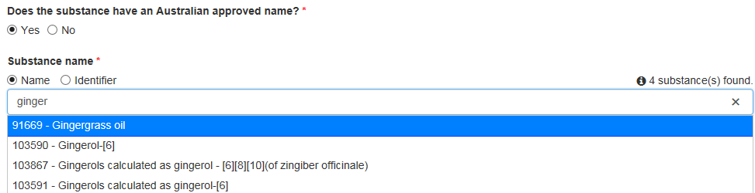

An ingredient name may change during the evaluation of the substance from the name initially proposed to align with TGA approved terminology for medicines. You will be consulted on this.

Application category
Select the application category using the drop down arrow.
For further information, see the guidance on application categories and the supporting information required in the Applications for new substances in listed medicines - Australian regulatory guidelines.
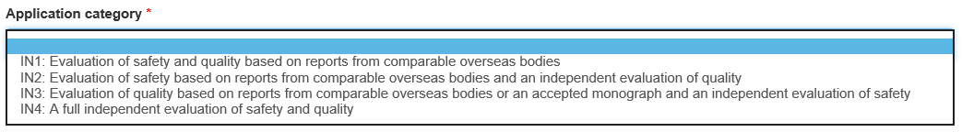

Application to modify an existing ingredient
Modify an existing ingredient in the Therapeutic Goods (Permissible Ingredients) Determination by selecting the ‘Modify the entry for an existing ingredient’ radio button.

Select the ingredient you propose to modify
The ingredient can be selected by entering the ingredient name or identifier. You can search for an ingredient name by entering a minimum of three characters.
The number of ingredients matching the search criteria will be displayed.
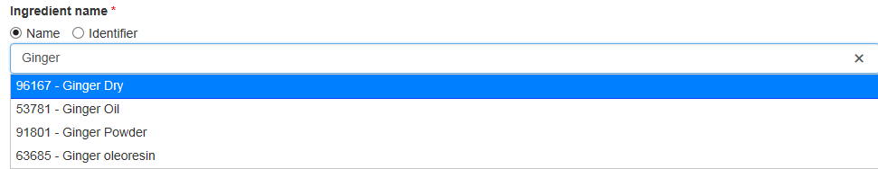
Select the appropriate ingredient name. The current information for the ingredient will be displayed:
- Ingredient identifier
- Ingredient name
- Availability
- Restrictions
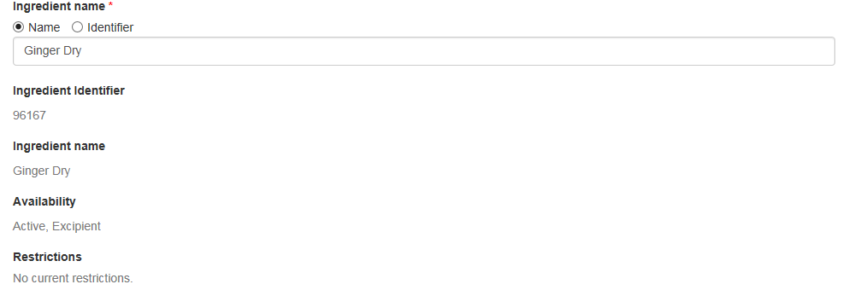

Application category
Select the application category using the drop down arrow.
For further information, see the guidance on application categories for evaluation of substances and the supporting information required in the Applications for new substances in listed medicines - Australian regulatory guidelines for further information.
The TGA makes use of assessments from comparable overseas bodies (COB), where possible, in evaluations for complementary medicines. For more information on the criteria for identifying COBs and accepting reports and a list of COBs, refer to Comparable overseas bodies (COBs) for complementary medicines

Related information, guidance and template
- Applications for new substances in listed medicines - Australian regulatory guidelines
- Information required in an evaluation of a substance for use in listed medicines: guidance for sponsors
- Compositional guidelines
- Compositional guideline template
When all mandatory fields have been completed, select ‘Next step’ to proceed to Step 3.
If you leave the page before selecting ‘Next Step’, any information already entered on that page will be lost. Information entered on previous complete pages will be saved. The application will appear under the draft tab of the Substance Evaluation dashboard.

Step 3 – Proposed use

Application to include a new substance
Select the proposed purpose of the ingredient when used in listed medicine using the radio buttons.
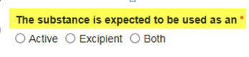
The Therapeutic Goods Regulations 1990 states that an active ingredient, for a medicine, means a therapeutically active component in the medicine’s final formulation that is responsible for its physiological or pharmacological action.
The Therapeutic Goods (Permissible Ingredients) Determination states that an excipient, for a medicine, means an ingredient that is not an active ingredient or a homoeopathic preparation ingredient.
Record the details of the intended purpose or therapeutic use of the ingredient in the free text box provided.
Add proposed routes of administration by selecting the ‘Add route(s) of administration’ button. Multiple routes of administration can be entered:
A window will appear. Select the proposed route of administration description from the list; alternatively, there is a search function in the top right hand corner, then select the magnifying glass.
You can select multiple routes of administration, which will appear at the bottom under ‘Selected Records’. If you wish to remove a description from the list, under ‘Selected Records’, select the cross button, at the bottom of the window.
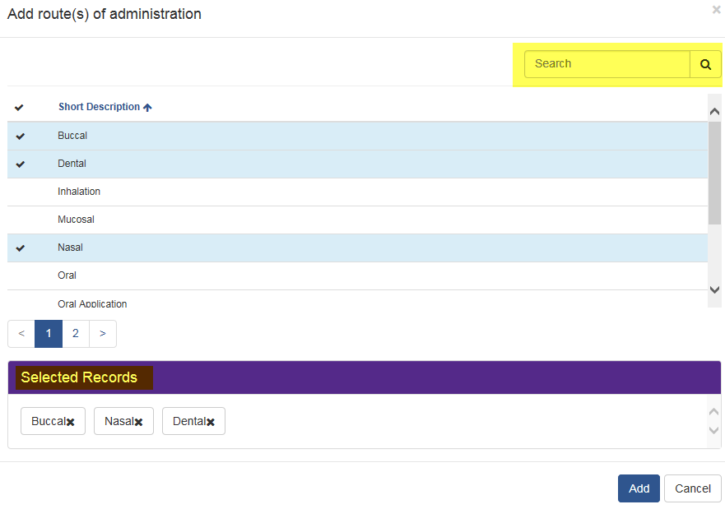
Once completed, select ‘Add’. The window will close and the selected route of administration(s) will be displayed.
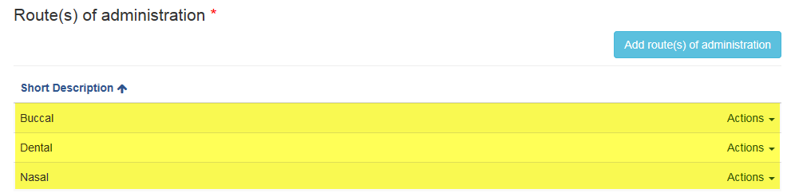
If you wish to delete a route of administration after they have been added, select the drop down arrow in the ‘Actions’ column next the route of administration you wish to remove and select ‘remove’.
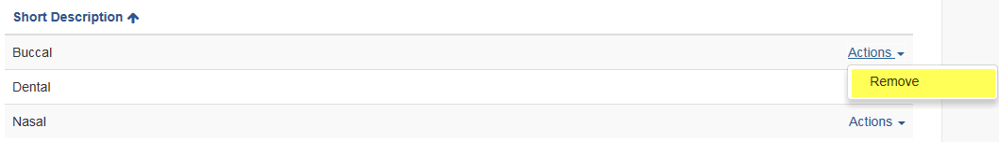
Complete the following information:
- Dosage form(s) – non-mandatory
- Dosage range – mandatory
- Frequency – mandatory
- Duration – mandatory
- Restrictions – non-mandatory

Application to modify an existing ingredient
If applicable, you will be able to propose a change to the ingredient purpose (or availability) when used in a listed medicine.
The current availability for the ingredient will be displayed. You will be asked either:
- Do you wish to extend the availability to include active use?
- Do you wish to extend the availability to include excipient use?
Complete the following fields:
- Dosage form(s) – non-mandatory
- Dosage range – mandatory
- Frequency – mandatory
- Duration – mandatory
- Do you wish to change the restrictions?
  - Yes – enter your restriction
  - No – no additional information is needed.
When all mandatory fields have been completed, select ‘Next step’ to proceed to Step 4.
If you wish to extend the availability of the ingredient to enable its use in homoeopathic preparations, include this in the restrictions.

Step 4 – Substance details
You will be required to complete the following mandatory fields:
- Is the substance a single constituent that can be readily characterised?
- Is the substance subject of a default standard?
- Is the substance of animal or human origin?

Is the substance a single constituent that can be readily characterised?
In the submission dossier, include all relevant information for simple and complex complementary substances as detailed in:
- Information required for an application for evaluation of a substance for use in listed complementary medicines

Is the substance subject of a default standard?
If ‘Yes’ is selected, the Monograph details box will appear. Add the monograph details by selecting the ‘Add a monograph’ button:
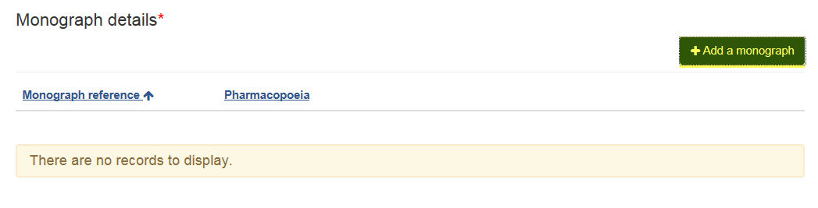
If ‘No’ is selected, a free text box will appear. Enter a ‘Description of structure and/or definition’. This is a text box only. Additional information or graphics should be included in the dossier.

Is the substance of animal or human origin?
If ‘Yes’ is selected, additional text will appear, which will advise of the information requirements to be included in the dossier.
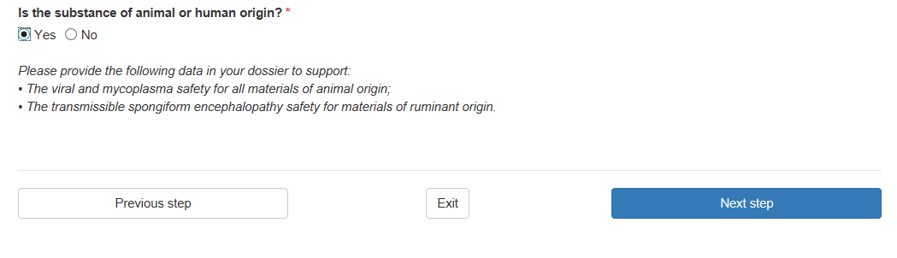
When all mandatory fields have been completed, select ‘Next step’ to proceed to Step 5.

Step 5 – Supporting documentation
Supporting data (submission dossier) can be attached to the application form (where less than 100mb) or sent separately to the TGA. The dossier must be included in a single zip file.

Attached to the application
Attach the data to the application by selecting the ‘Attached’ button and then the ‘Add a supporting document’ button:
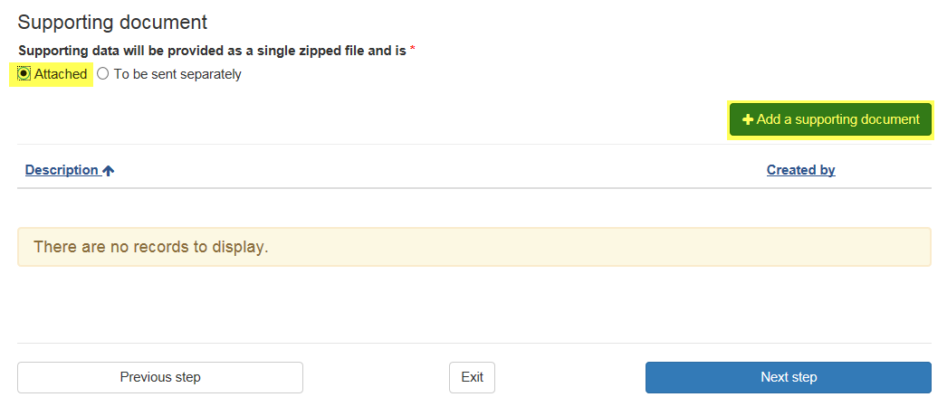
When the ‘Attachment Details’ window opens, enter a description for the document.
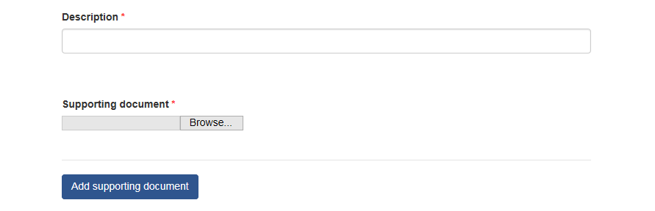
Select ‘Browse’ to search for the file.
Select ‘Save & close’.
The file will appear under the ‘Description’ heading. If you wish to delete the document, select ‘Actions’ and ‘Remove’.
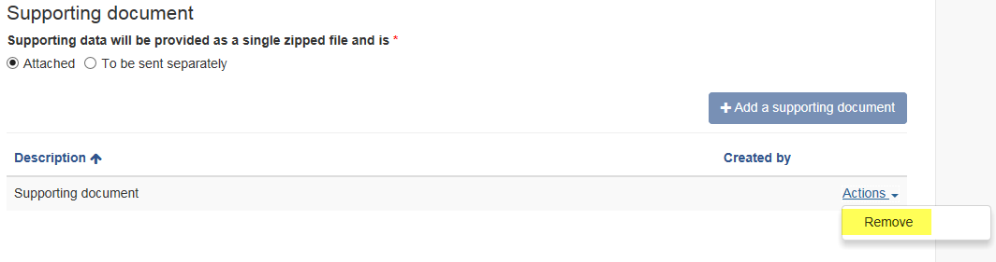
You can only upload a single zipped file with a file size less than 100mb.

Send separately
If you are unable to upload your supporting data, you can advise us that you will send it separately by selecting ‘To be sent separately’ radio button.
The dossier can be emailed to: complementary.medicines@health.gov.au.
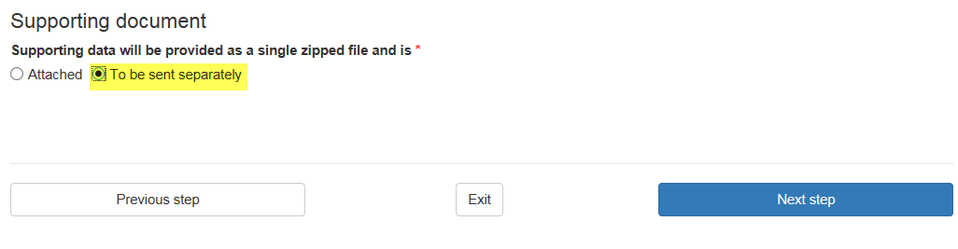
Ensure the submission dossier includes information as set out in Table 1: Application categories for evaluation of substances.
When all mandatory fields have been completed, select ‘Next step’ to proceed to Step 6.

Step 6 – Declaration
The application summary and declaration will be displayed.

Application summary
View a full summary of the application prior to submission by selecting the ‘Print draft application’ button on the top right hand side of the window.
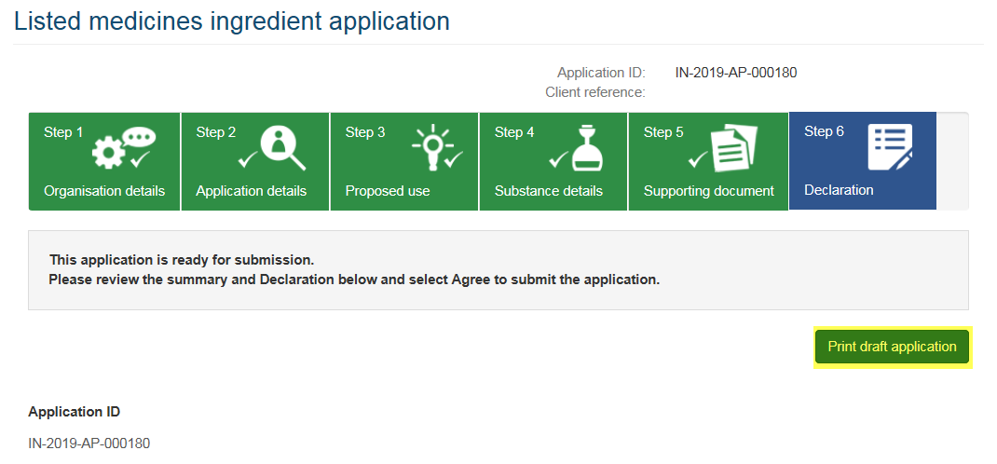
If you are using Internet Explorer, a box will display at the bottom of the page with the option to ‘Open’ or ‘Save’.
If you are using Google Chrome, a box will appear in the bottom left side, containing the PDF document.
Other web browsers may display differently.
Once opened, a PDF document will display the information included in the application.
This document will enable you to review all details entered into the application.

Declaration
An application form cannot be submitted unless the declaration has been agreed.
Read the Declaration. Select either the ‘Agree’ or ‘Disagree’ button.
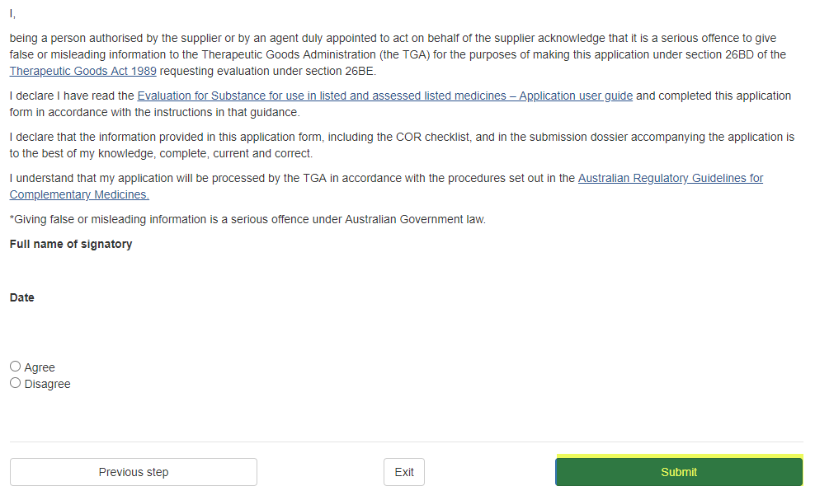
If you select ‘Disagree’, you will be unable to submit your application. The following message will appear.
To navigate back to the Substance Evaluation dashboard, select the ‘Dashboard’ link on the top left hand side of the page, as below or select ‘Exit’.
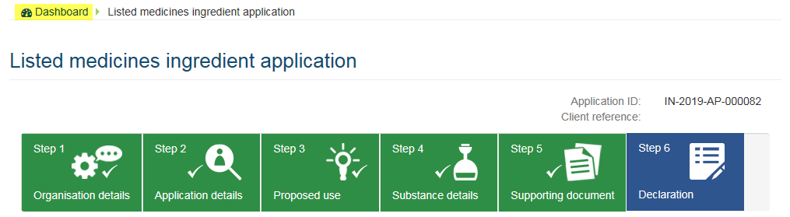
The application will be saved to ‘Drafts’ where it can be edited and submitted at a later stage.
To proceed with the submission of the application, you must agree to the Declaration.
When you select ‘Agree’ and the ‘Submit’ button, the application will be submitted.
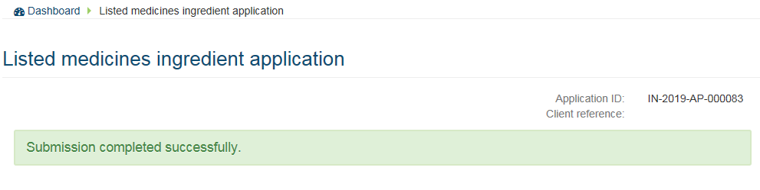

After submission
An invoice will be automatically generated for the application fee. The invoice will be emailed to the applicant or organisation who was nominated as being responsible (see Who is responsible for payment of the invoice?). The invoice can be viewed in the ‘$ Financial’ menu by users with a ‘financial’ role.
A separate invoice will be sent for the evaluation fee after the application has passed preliminary assessment.
Preliminary assessment of the application will not commence until the application fee is paid.
To navigate back to the Substance Evaluation dashboard, select the ‘Dashboard’ link on the top left hand side of the page.
View the summary of the application, by selecting the ‘Submitted’ tab. Select ‘Actions’ and ‘View summary’. Information provided in the application will be displayed.
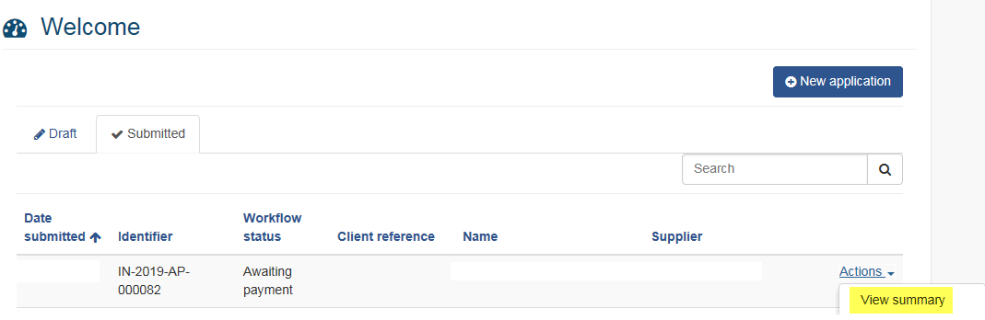

Fees
The application and evaluation fees are based on the selected application category. Once you have submitted your application you will receive an invoice for the application fee. On payment of this invoice, your application will progress to preliminary assessment.
An invoice for the evaluation fee will be sent once the application has passed preliminary assessment and been accepted for evaluation. Evaluation of the application will not commence until the evaluation fee is paid.

Related information and guidance
- Fees & payments - Current fees
- Fees & payments - Payment options

Troubleshooting
The below error message is an indication that the application portal has timed out:
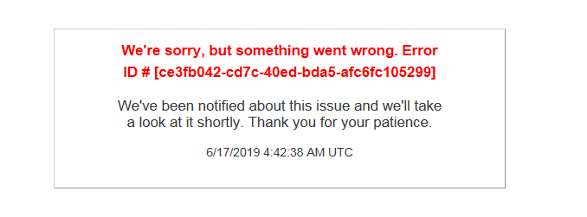
To resume the application, select the ‘Back’ arrow on your internet browser to reload the page. This will take you back to the application.
Alternatively, log back in to the TGA Business Portal. Your application will appear in the drafts tab. Any information that was not saved on the page you were completing will be lost. Information entered on previous pages will be saved.

Version history
Version | Description of change | Author | Effective date
V1.0 | Original publication | Complementary and OTC Medicines | September 2019
V2.0 | Changes made to include assessed listed medicines, changes to sections 26BD and 26BE of the Act and to the guidelines documentation | Complementary and OTC Medicines Branch | August 2020

Therapeutic Goods Administration
PO Box 100 Woden ACT 2606 Australia
Email: info@tga.gov.au Phone: 1800 020 653 Fax: 02 6203 1605
https://www.tga.gov.au
Reference/Publication #

